Method : Three Bill of Exchange with Discounting & Dishonour

Step 1: Bill of Exchange Payment F-36 (Same as that for simple Method)
Refer : S.No. 02- FI-AR- 06 document for making Bill of Exchange Payment
Step 2: Bill of Exchange Discounting F-33 (same as that for simple method)
Refer : S.No. 02- FI-AR- 07 document for making Bill of Exchange Discounting
Step:3 Bill of Exchange Reverse Contingent Liability F-20 (same as simple method
(Refer : S.No. 02- FI-AR- 08)
Step 3: As under

S.NO. : 02- FI-AR- 10

TRANSACTION CODE : F – 21

ACCESS PATH :SAP Easy Access Accounting Financial
Accounting Accounts Receivable Document Entry
Other Int. Transfer Posting Without
Clearing

We get “ Enter Transfer Posting – Header Data” screen ;

Required Fields:

Document date : To be entered
Account : To be entered (Customer A/c Number)
Posting Key : 04 to be entered

Rest all other fields viz, Doc Type, Period, Companycode,Currency/Rate are default after they are entered for the first time.

We get the Screen “Enter Transfer Posting - Header Data“ incorporating the above
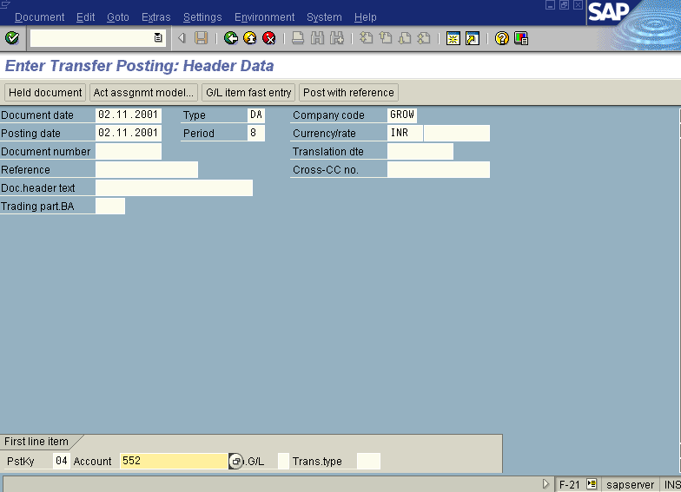
mentioned required fields as under;

Press Enter button

We get “Enter customer Document : Add Customer Item” Screen as under

In the above screen enter the amount, text, Pstkey, account, bline date etc.

Incorporating the above fields the screen will appear as under
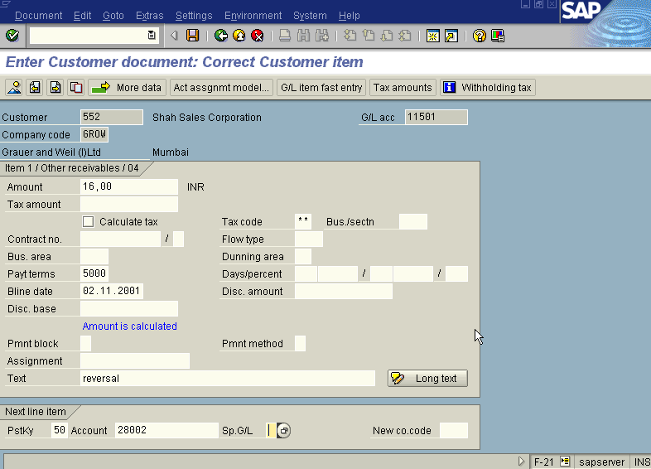

Press Save button

The system will display the message as under

Take the note of the above number 1600094.

The document can be seen from Document Display from the top left hand side of the main screen “Enter Transfer posting - Header Data“ OR from Transaction code FB- 03 .The Document overview screen will be displayed as under showing the entries.

